Vulnerability Report for DemoBlaze.com by Saquibh Shaikh

1.Vulnerability: Hardcoded Sensitive Information in Source Code

# 1. Vulnerability Summary

* Vulnerability Name: Hardcoded Sensitive Information (Secrets)
* OWASP Category:
* - A02:2021 - Cryptographic Failures
* - A07:2021 - Identification and Authentication Failures (if related to credentials)
* Severity Level: High / Critical (based on sensitivity of the exposed secret)
* Status: Open

# 2. Vulnerability Description

* Hardcoded sensitive information, such as API keys, authentication tokens, or passwords, was found embedded directly within the source code of demoblaze.com.
* Exposing such secrets publicly (e.g., through public repositories or client-side code like JavaScript) poses a severe security risk, as attackers can misuse these secrets to access sensitive resources, escalate privileges, or compromise the system.

# 3. Proof of Concept (PoC)

* Location: :https://www.demoblaze.com/index.html (Example file name or source code file).
* Sensitive Data Found: Harded coded Password
* Code Snippet (PoC):

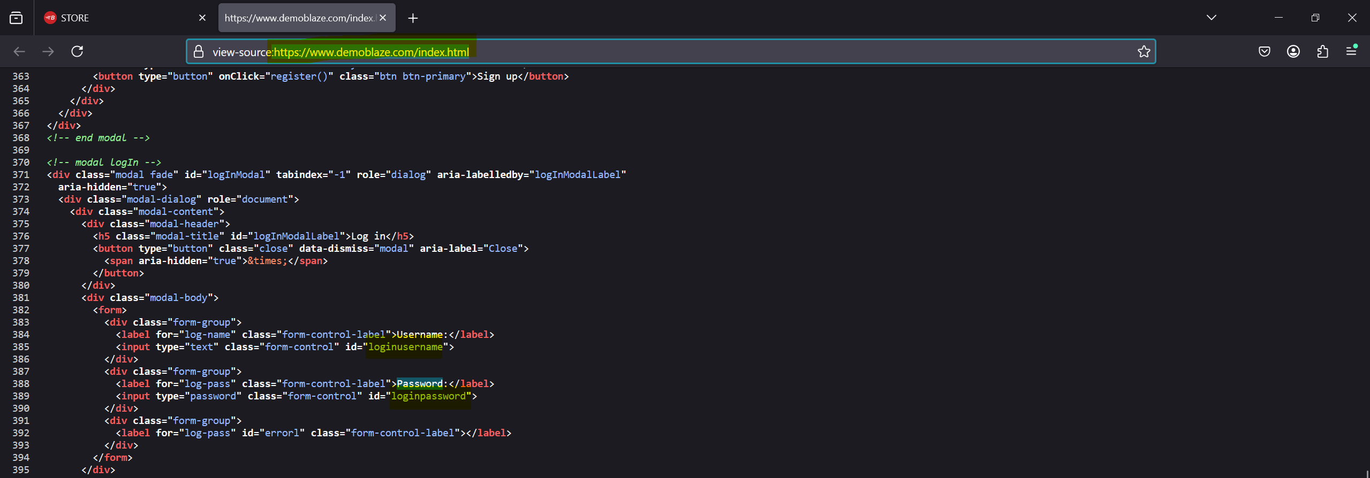

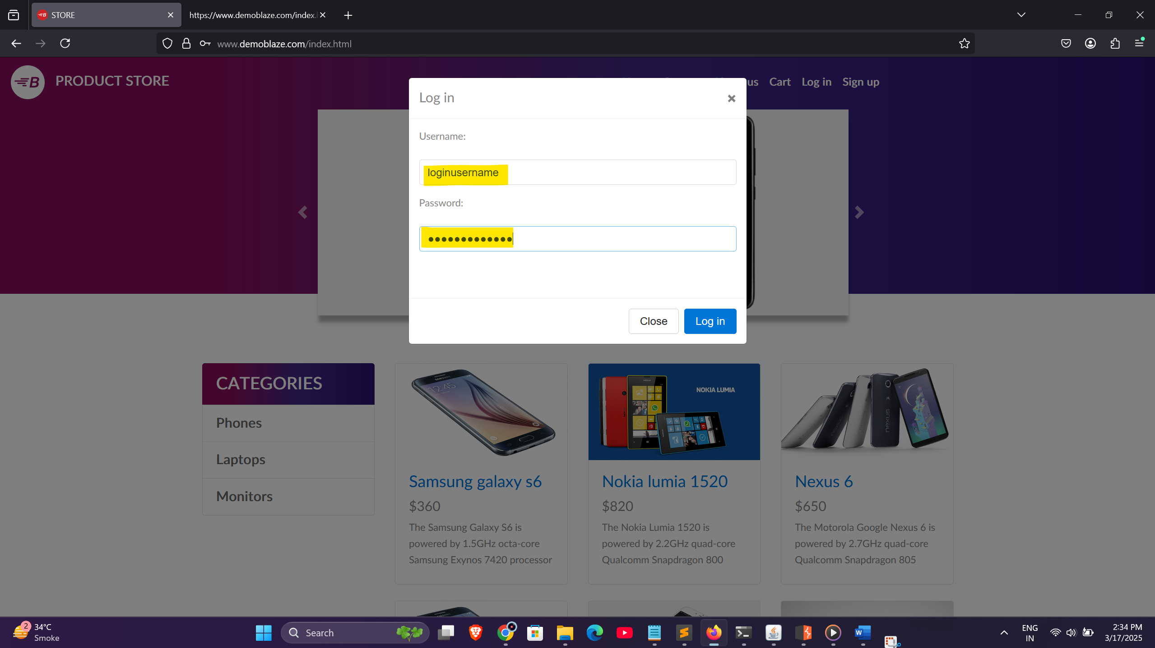

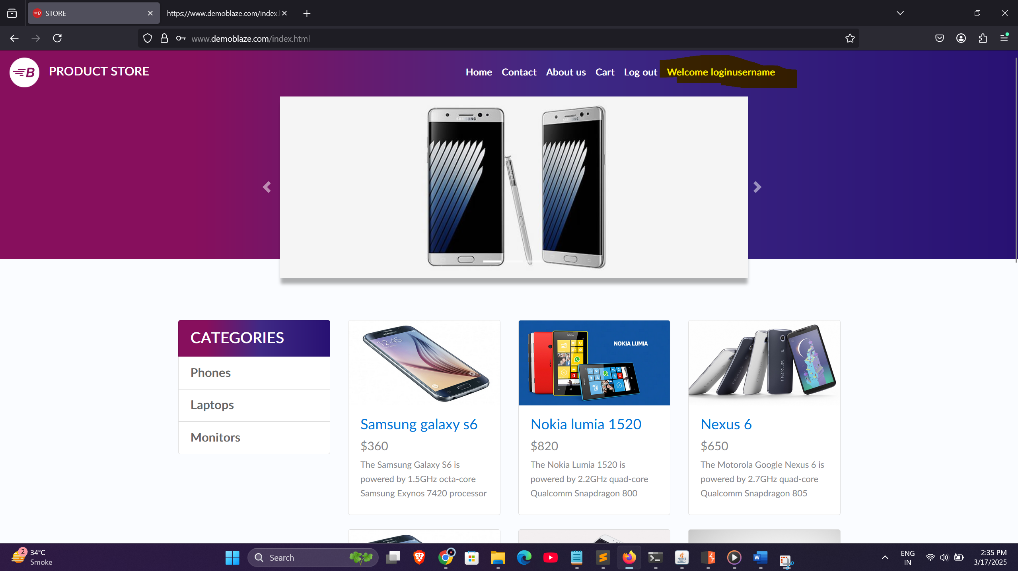

* Step-by-Step Reproduction:
* 1. Navigate to https://www.demoblaze.com.
* 2. Open browser Developer Tools (Right click → Inspect → "viewpage.source" tab).
* 3. Locate and search for index.html.
* 4. Search for sensitive keywords like password , username .
* 5. You will see default hardcoded password and username in login form inside div

# 4. Artifact / Evidence

* Screenshot (example):







* File name and line number (if available):index.html , Line: 385 and 389 (Example)

# 5. Impact

* Unauthorized access to sensitive password and username
* Potential data breach (confidential data exposure).
* Privilege escalation if the key/token belongs to admin functionality.
* Abuse of backend services (e.g., sending malicious requests using valid keys).

# 6. Risk Level

* Likelihood: High
* Impact: High / Critical
* Overall Risk Level: Critical

# 7. Recommendations / Remediation

* Never hardcode sensitive information like API keys, tokens, or passwords in source code, especially on the client side (JavaScript).
* Use environment variables and securely store them on the server side only.
* Regenerate/rotate compromised secrets immediately.
* Utilize Secrets Management Solutions (e.g., AWS Secrets Manager, Azure Key Vault, Vault by HashiCorp).
* Implement CI/CD pipeline checks to detect hardcoded secrets automatically (e.g., TruffleHog, GitLeaks).
* Conduct regular code reviews to detect and prevent such issues before release.
* Set least privilege permissions on API keys.

# 8. References

* OWASP A02:2021 - Cryptographic Failures: https://owasp.org/Top10/A02_2021-Cryptographic_Failures/
* OWASP A07:2021 - Identification and Authentication Failures: https://owasp.org/Top10/A07_2021-Identification_and_Authentication_Failures/
* OWASP Secrets Management Cheat Sheet: https://cheatsheetseries.owasp.org/cheatsheets/Secrets_Management_Cheat_Sheet.html

# 9. Conclusion

* This vulnerability can lead to severe compromise of user data and application integrity. It is recommended to address this issue immediately by revoking exposed keys, rotating secrets, and updating the application to securely manage sensitive information.

2.Vulnerability - Outdated JavaScript version

# 1. Vulnerability Summary

* Vulnerability Name: Use of Vulnerable and Outdated JavaScript Libraries
* OWASP Category: A06:2021 - Vulnerable and Outdated Components
* Severity Level: High
* Status: Open

# 2. Vulnerability Description

* The application includes outdated JavaScript libraries which are known to have public vulnerabilities. Such vulnerabilities can allow attackers to exploit known issues like Cross-Site Scripting (XSS), prototype pollution, or even remote code execution depending on the library and version.

# 3. Proof of Concept (PoC)

* Location: Homepage (index.html)
* Issue: Use of outdated jQuery version 1.7.1 which is known to have XSS vulnerabilities.
* PoC Code Snippet:

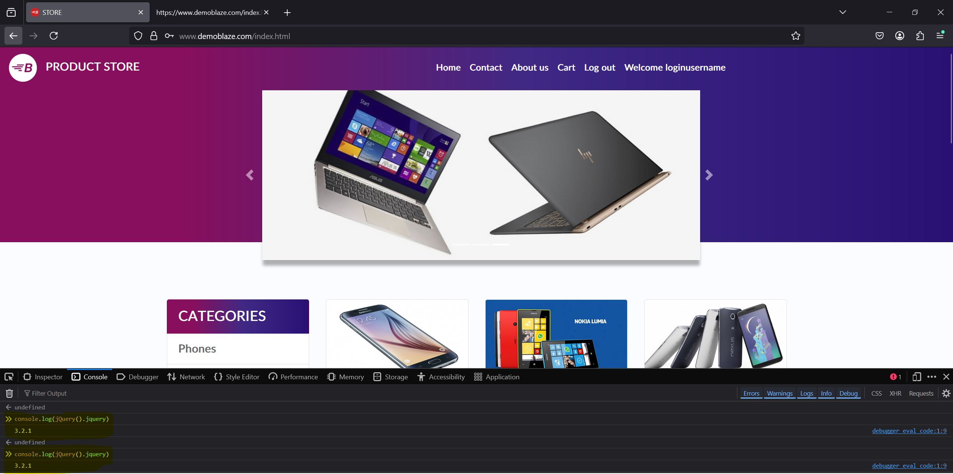

* Step-by-Step Reproduction:
* 1. Navigate to https://www.demoblaze.com.
* 2. Open browser Developer Tools (Right click → Inspect → "click on Inspect Q" tab).
* 3. Inside inspect-Q in browser locate for console tab click on it
* 4. Enter the javascript code i.e console.log(jQuery().jquery)
* 5. You will see the version of javascript 3.2.1 which is outdated version.

# 4. Artifact / Evidence

* Screenshot of source code showing reference to outdated jQuery version.



# 5. Impact

* Exploitation of client-side vulnerabilities such as XSS.
* Possible prototype pollution leading to privilege escalation.
* Compromised client-side security resulting in unauthorized access or data leakage.

# 6. Risk Level

* Likelihood: High
* Impact: High
* Overall Risk Level: High

# 7. Recommendations / Remediation

* Upgrade jQuery to the latest stable version (3.6.0 or later).
* Perform a full dependency review to ensure no other outdated JS libraries are in use.
* Use Subresource Integrity (SRI) to ensure that resources hosted on third-party CDNs have not been tampered with.
* Integrate automated tools like Retire.js or Snyk for continuous monitoring of library versions.

# 8. References

* https://owasp.org/Top10/A06_2021-Vulnerable_and_Outdated_Components/
* https://nvd.nist.gov/vuln/detail/CVE-2015-9251

# 9. Conclusion

* The presence of outdated JavaScript libraries introduces significant risks and should be addressed immediately. Upgrading to patched versions and implementing security monitoring for dependencies is strongly recommended.

Vulnerability Report - Session Fixation via Reusable Session Token

# 1. Vulnerability Summary

* Vulnerability Name: Session Fixation via Reusable Session Token
* OWASP Category:
* - A01:2021 - Broken Access Control
* - A07:2021 - Identification and Authentication Failures
* Severity Level: High
* Status: Open
* CVE ID (Example): Not Applicable (Custom vulnerability)

# 2. Vulnerability Description

* The application allows the reuse of an old session token even after the user logs out, indicating a Session Fixation vulnerability. This flaw allows attackers to hijack authenticated user sessions, leading to unauthorized access and potential account takeover.

# 3. Proof of Concept (PoC)

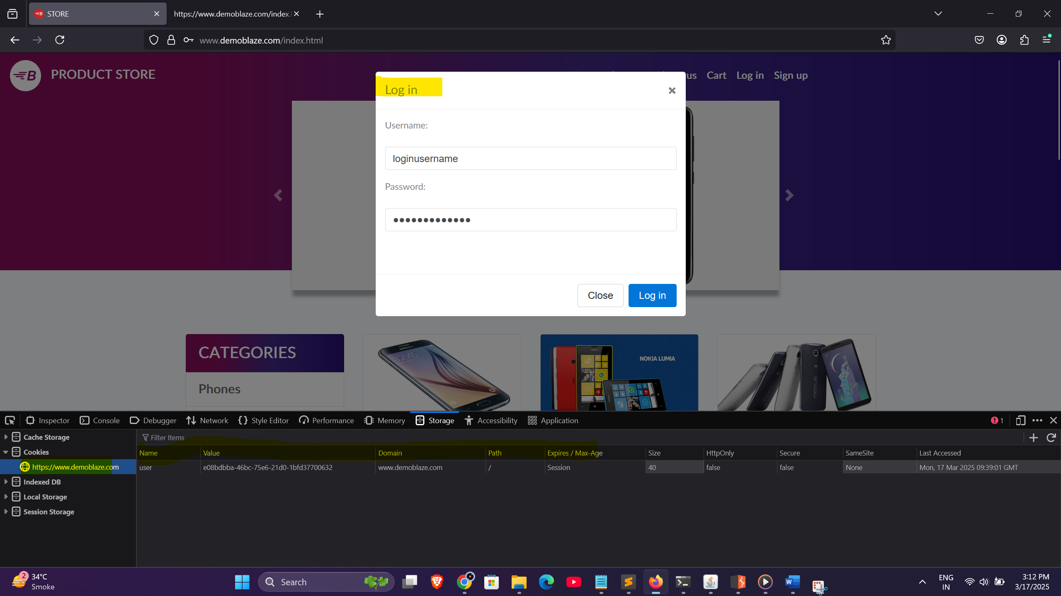

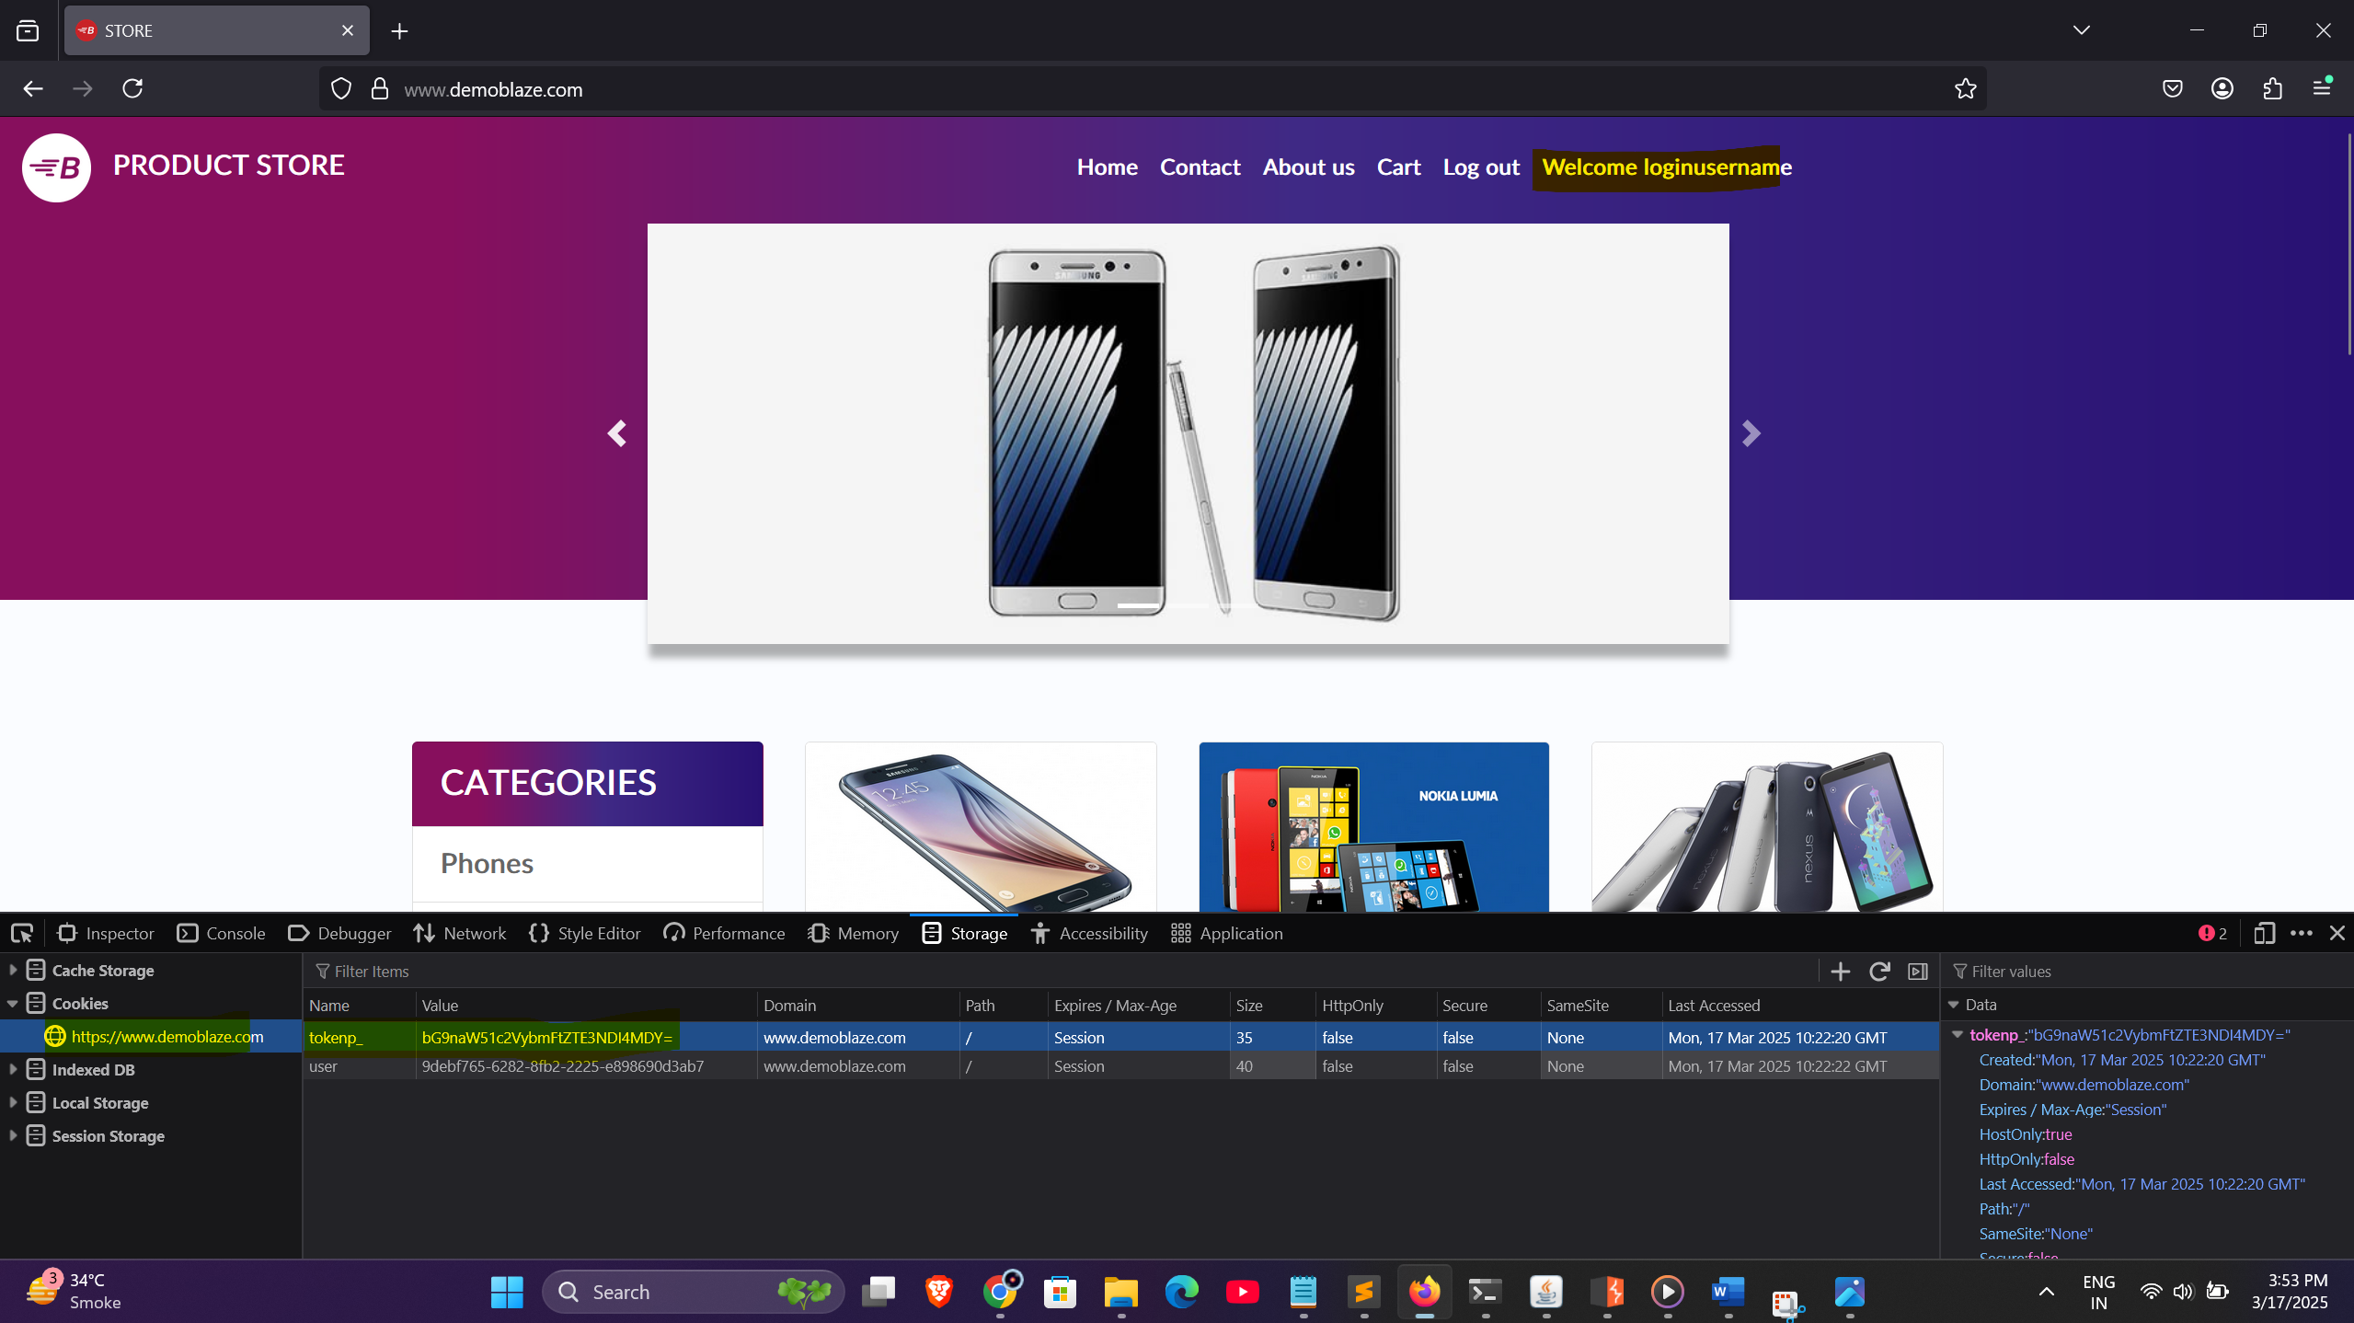

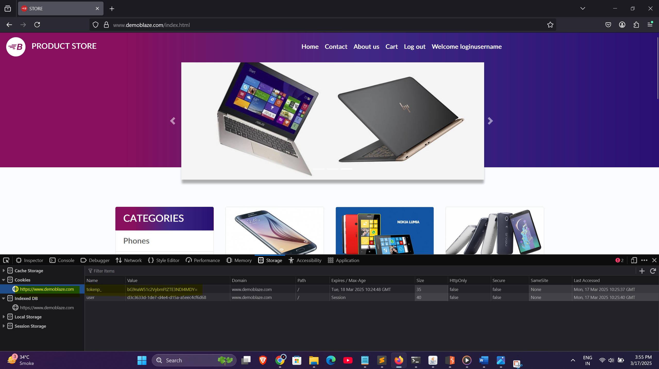

* Step 1: Login to the application and capture the session cookie (e.g., PHPSESSID= bG9naW51c2VybmFtZTE3NDI4MDY=).
* Step 2: Copy the session cookie value and store it locally (e.g., Notepad).
* Step 3: Log out from the application normally.
* Step 4: Open browser DevTools -> Application -> Cookies and replace the cookie value with the old session token (PHPSESSID= bG9naW51c2VybmFtZTE3NDI4MDY=).
* Step 5: Refresh the browser or access any authenticated endpoint.
* Result: The application accepts the reused session token and logs the user back in, demonstrating successful session fixation.

# 4. Artifact / Evidence



* Captured valid session cookie before logout: PHPSESSID= bG9naW51c2VybmFtZTE3NDI4MDY=
* Reusing the same cookie after logout successfully restored access to the authenticated session.
* Screenshots and intercepted requests (Browser DevTools) can be attached as evidence.
* Tool Used: Browser DevTools.

# 5. Impact

* Full account takeover risk if attackers set a fixed session token for victims.
* Exposure of sensitive data, potential data breaches.
* Violation of access control and authentication mechanisms.
* Non-compliance with security standards such as GDPR, PCI-DSS, and OWASP ASVS.

# 6. Risk Level

* Likelihood: High
* Impact: High
* Overall Risk Level: Critical

# 7. Recommendations / Remediation

* Regenerate session ID upon successful login to prevent reuse of existing tokens.
* Invalidate and destroy sessions on user logout both on the client and server sides.
* Implement proper session expiration and timeout mechanisms.
* Use secure cookie attributes:
* - HttpOnly: Prevent access via JavaScript.
* - Secure: Ensure cookies are sent over HTTPS only.
* - SameSite=Strict: Protect against CSRF attacks.
* Avoid accepting session IDs via URLs (GET parameters).
* Conduct regular security reviews and session management tests.

# 8. References

* https://owasp.org/Top10/A01_2021-Broken_Access_Control/
* https://owasp.org/Top10/A07_2021-Identification_and_Authentication_Failures/
* https://cheatsheetseries.owasp.org/cheatsheets/Session_Management_Cheat_Sheet.html
* https://portswigger.net/web-security/session-fixation

# 9. Conclusion

* The identified Session Fixation vulnerability poses a severe security risk, enabling attackers to hijack authenticated user sessions. Immediate mitigation is recommended by regenerating session IDs post-login and invalidating sessions upon logout.

Vulnerability Report - SQL Injection in Login Page

# 1. Vulnerability Summary

* Vulnerability Name: SQL Injection in Login Page
* OWASP Category:
* - A03:2021 - Injection (SQL Injection)
* Severity Level: Critical
* Status: Open

# 2. Vulnerability Description

* The application login page is vulnerable to SQL Injection, allowing attackers to manipulate backend SQL queries. This may result in unauthorized access to user accounts, data leakage, and potentially complete database compromise.

# 3. Proof of Concept (PoC)

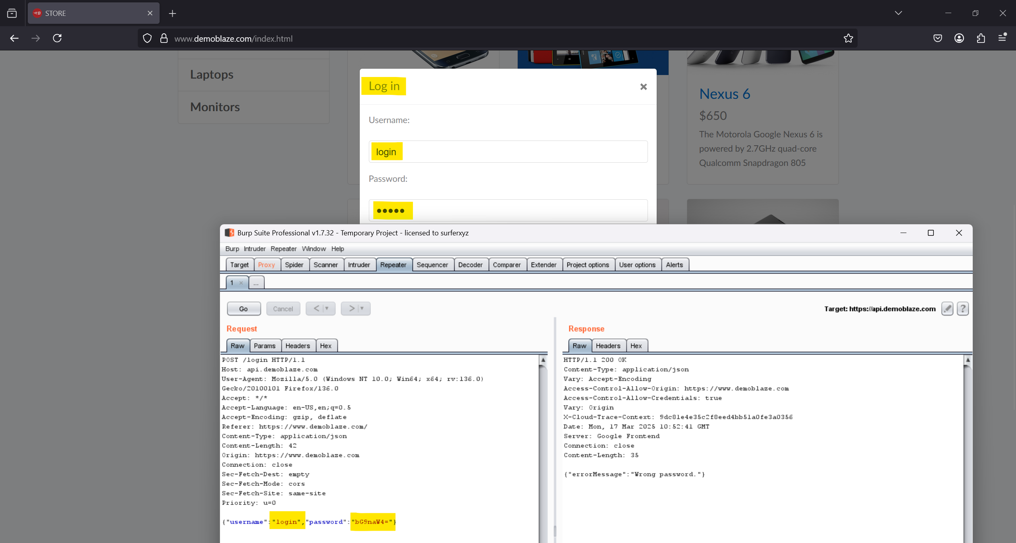

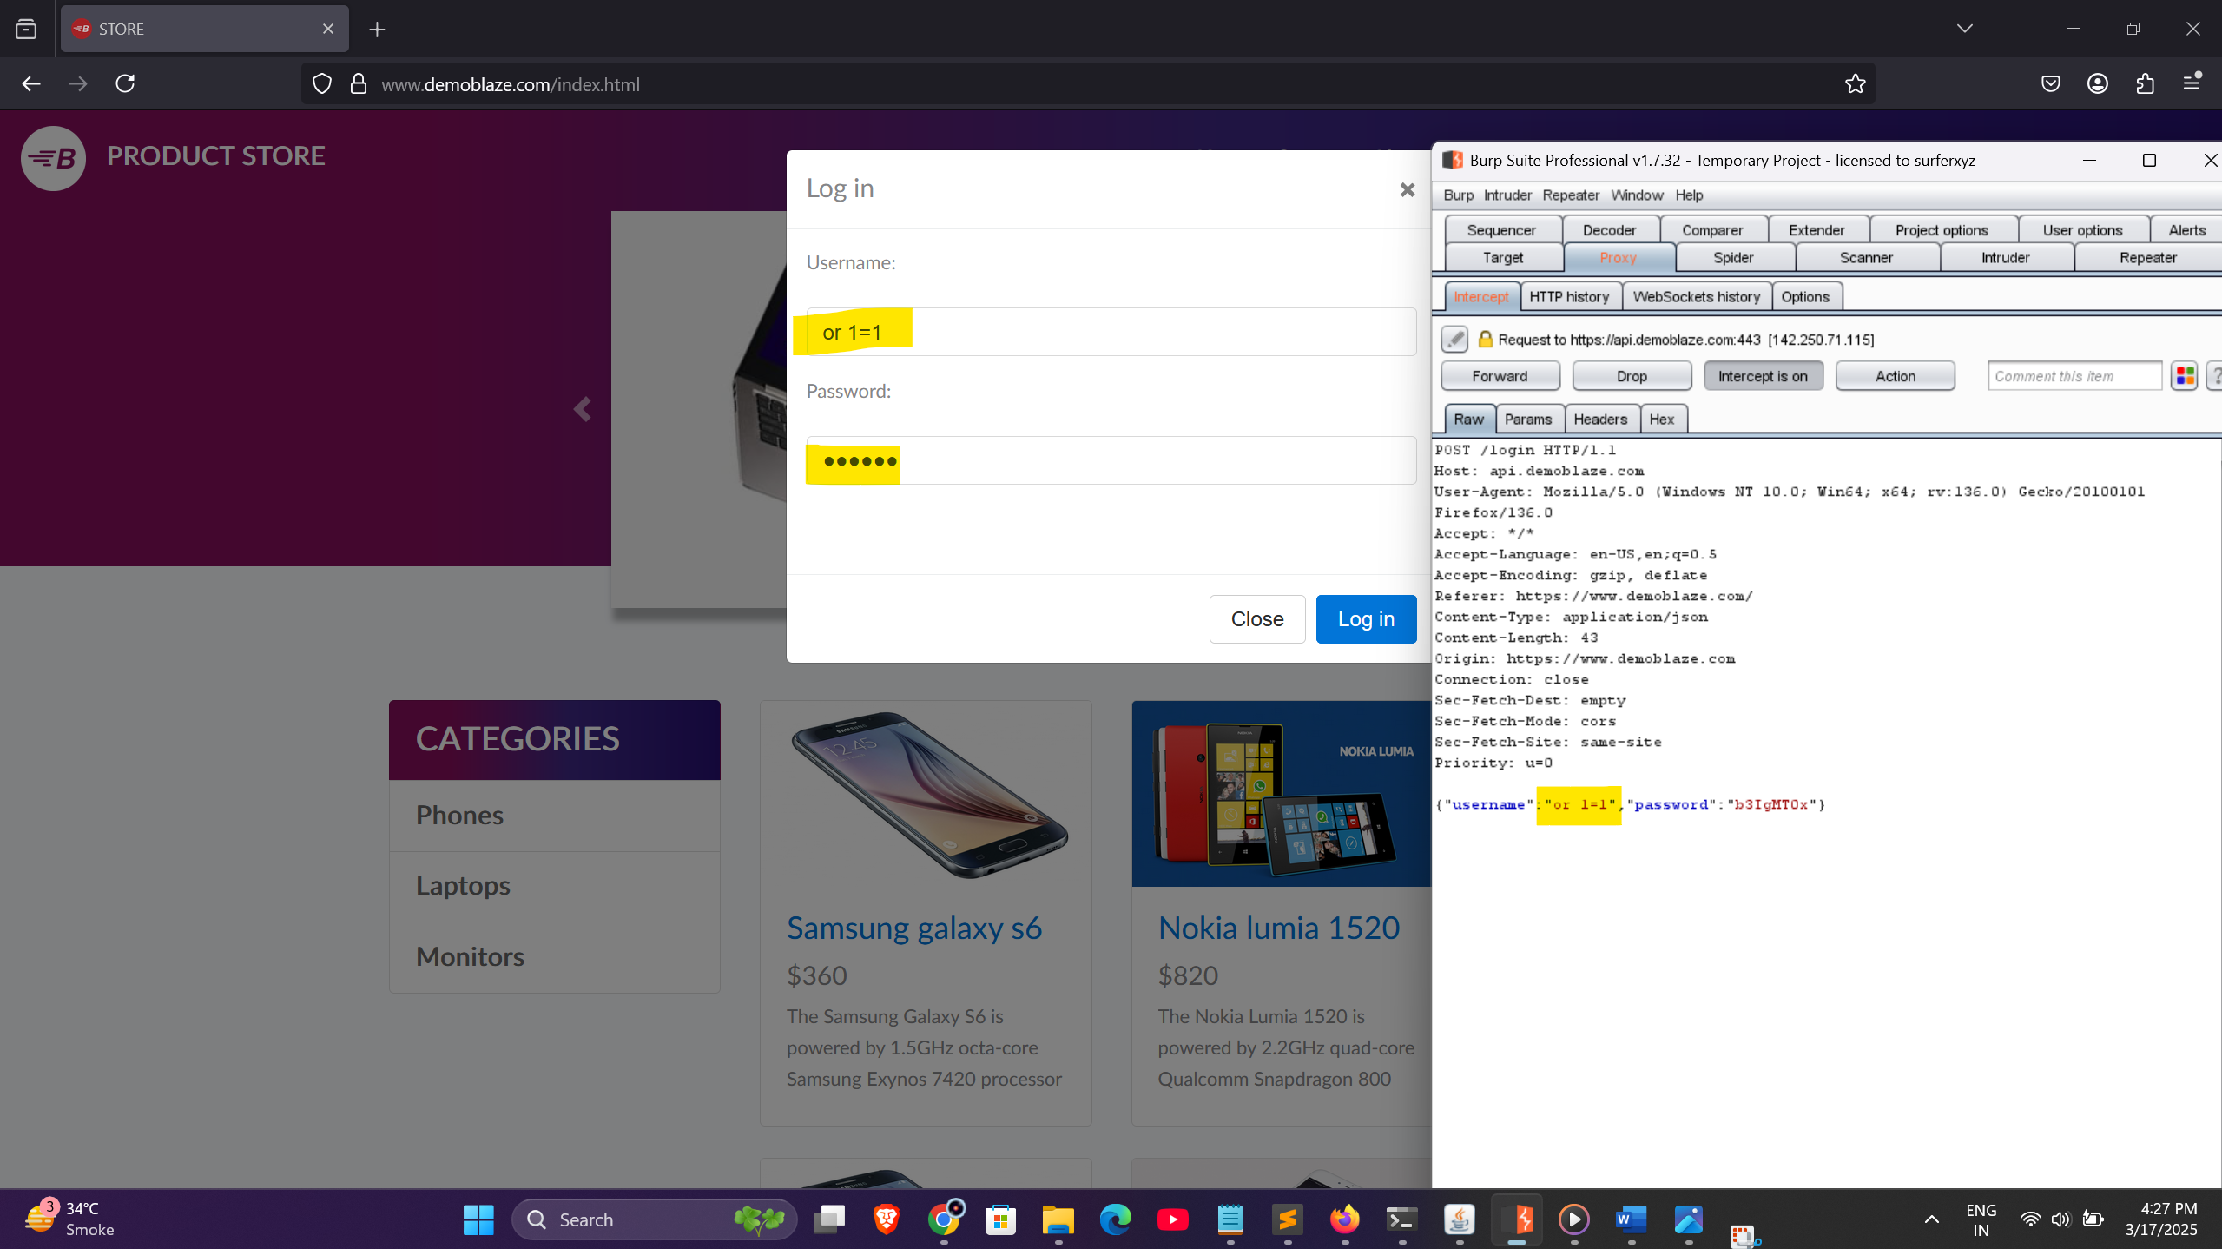

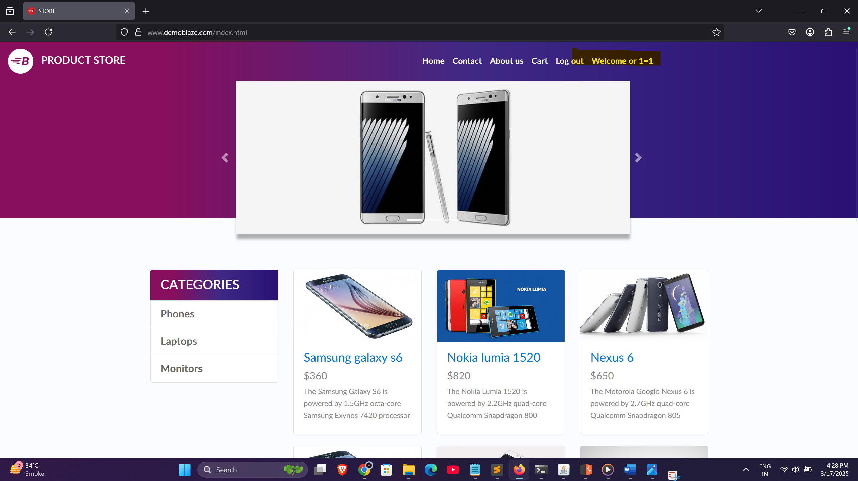

* Step 1: Go to the login page of the application and intercept post request.
* Step 2: In the username field and password , input payload: OR 1=1
* Step 3: Intercept the login request using Burp Suite to verify the payload.
* Step 4: Submit the login form.
* Result: Successfully bypassed authentication and logged in as an administrator or other valid user, demonstrating SQL Injection vulnerability.

# 4. Artifact / Evidence





* Tools Used: Burp Suite, Browser DevTools.

# 5. Impact

* Full unauthorized access to user accounts including administrator.
* Potential exposure of sensitive data from the database (PII, credentials).
* Database manipulation or deletion (if exploited further).
* Complete compromise of application security.

# 6. Risk Level

* Likelihood: High
* Impact: Critical
* Overall Risk Level: Critical

# 7. Recommendations / Remediation

* Use parameterized queries (Prepared Statements) to interact with databases.
* Implement ORM (Object Relational Mapping) frameworks that abstract raw SQL queries.
* Perform input validation and sanitization on all user inputs.
* Use stored procedures for database interactions where appropriate.
* Apply least privilege principle for database accounts (avoid using admin/root accounts for application connections).
* Conduct regular code review and security testing (DAST, SAST).
* Enable Web Application Firewall (WAF) to detect and block injection attempts.

# 8. References

* https://owasp.org/Top10/A03_2021-Injection/
* https://portswigger.net/web-security/sql-injection
* https://cheatsheetseries.owasp.org/cheatsheets/SQL_Injection_Prevention_Cheat_Sheet.html

# 9. Conclusion

* The identified SQL Injection vulnerability allows bypassing authentication, posing a severe risk to the application and user data. Immediate remediation is advised to prevent potential exploitation.